Miss. Tejashree Suresh Phatak
PhD- Pursuing, University of Mumbai, Vivekanand Education Society's Institute of Technology
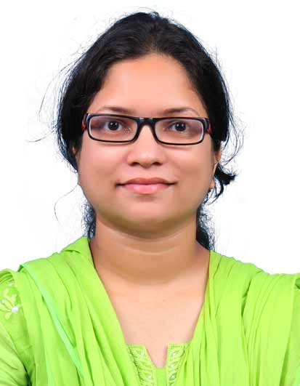
M.E. Electronics & Telecommunication, University of Mumbai.
B.E. Electronics & Telecommunications, University of Mumbai
Residence : 1001, Shubhachintan CHS, Nahur East, Mumbai 400042
EmailId : tejashree.phatak@mctrgit.ac.in
Cell No :8692892372
_______________________________________________________________________________
Designation : Assistant Professor in Electronics & Telecommunication Department.
Experience : Educational: 6 Months
Industry: 2 years
Research Fellow : 4 Year
Date of Joining :18/07/2016
____________________________________________________________________________________
Areas of Interest : Artificial Intelligent and Machine learning

Publications :

International Journals : 02

- Tejashree S. Phatak, J. Nair, S. Prasanna Ram, and B. J. Roy, ‘Evaluation of Neutron Cross-Section Data Using Gaussian Mixture Model and Digital Filter’, Nuclear Science and Engineering, Taylor & Francis,pp. 1–24., 2023.
- Tejashree S. Phatak, J. Nair, S. Prasanna Ram, B. J. Roy, and G. Mohanto, Regression analysis of experimental reaction cross-section data of 241Am(n, 2n)240Am,European Physics Journal Web of Conferences, vol. 284, 05 2023.

International Conferences : 03

- Tejashree S. Phatak, J. Nair, S. P. Ram, B. J. Roy and G. Mohanto, ”Non-Linear Unscented Transformation Techniques for Error Estimation of HPGe Detector Efficiency,” 2022 5th International Conference on Advances in Science and Technology (ICAST), Mumbai, India, 2022, pp. 647-653, doi: 10.1109/ICAST55766. 2022.10039524
- Tejashree S. Phatak, J. Nair, S. Prasanna Ram, B. Roy, and G. Mohanto, Evaluation of Neutron Cross-Section Data of 241Am(n, 2n) 240Am Reaction Using Gaussian Process Concept, 09 2023, pp. 613625.
- Tejashree S. Phatak and S. D. Sawarkar, "Enhancing QoS of Wireless Sensor Network by detection of faulty sensor node," 2016 International Conference on Computing, Analytics and Security Trends (CAST), Pune, India, 2016, pp. 100-105, doi: 10.1109/CAST.2016.7914948.

Others:
- Nptel swayam course :
- Regression Analysis
- Introduction to machine learning
- Artificial intelligence: Search method for problem solving.
- Nptel Workshop: Data visualization with R
- Workshop on Machine learning and Deep learning

